**VISVESVARAYA TECHNOLOGICAL UNIVERSITY**



**“JnanaSangama”, Belgaum -590014, Karnataka.**

**LAB RECORD**

Bio Inspired Systems (23CS5BSBIS)

***Submitted by***

**PRATIK JANA(1BM22CS356)**

***in partial fulfillment for the award of the degree of***

**BACHELOR OF ENGINEERING**

***in***

**COMPUTER SCIENCE AND ENGINEERING**

**B.M.S. COLLEGE OF ENGINEERING**

**(Autonomous Institution under VTU)**

**BENGALURU-560019**

**Sep-2024 to Jan-2025**

**B.M.S. College of Engineering,**

**Bull Temple Road, Bangalore 560019**

(Affiliated To Visvesvaraya Technological University, Belgaum)

**Department of Computer Science and Engineering**



**CERTIFICATE**

This is to certify that the Lab work entitled “Bio Inspired Systems (23CS5BSBIS)” carried out by **PRATIK JANA (1BM22CS356),** who is bonafide student of **B.M.S. College of Engineering.** It is in partial fulfillment for the award of **Bachelor of Engineering in Computer Science and Engineering** of the Visvesvaraya Technological University, Belgaum. The Lab report has been approved as it satisfies the academic requirements of the above mentioned subject and the work prescribed for the said degree.

Dr. Kavitha Sooda Professor & HOD

Department of CSE, BMSCE

Prof. Saritha A N Assistant Professor

Department of CSE, BMSCE

**Index**

|  |  |  |  |
| --- | --- | --- | --- |
| **Sl.**  **No.** | **Date** | **Experiment Title** | **Page No.** |
| 1 | 24/10/24 | Genetic Algorithm for Optimization Problems | 1-4 |
| 2 | 7/11/24 | Particle Swarm Optimization for Function Optimization | 5-8 |
| 3 | 14/11/24 | Ant Colony Optimization for the Traveling Salesman Problem | 9-14 |
| 4 | 21/11/24 | Cuckoo Search (CS) | 15-18 |
| 5 | 28/11/24 | Grey Wolf Optimizer (GWO) | 19-23 |
| 6 | 19/12/24 | Parallel Cellular Algorithms and Programs | 24-27 |
| 7 | 19/12/24 | Optimization via Gene Expression Algorithms | 28-32 |

Github Link: https://github.com/AnkitSB19/BISLAB_1BM22CS353

Algorithm:

# Program 1

## Genetic Algorithm for Optimization Problems

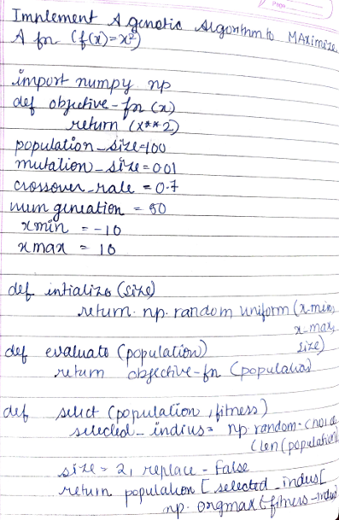

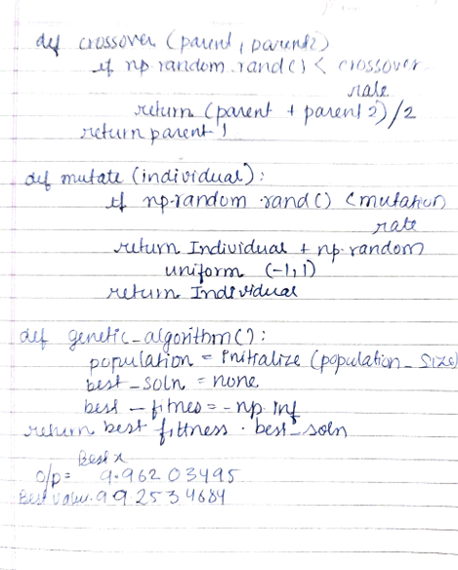

Code:

import numpy as np

# Define the objective function def objective_function(x):

return x**2

# Initialize parameters population_size = 100

mutation_rate = 0.01

crossover_rate = 0.7

num_generations = 50

x_min = -10

x_max = 10

# Create initial population

def initialize_population(size):

return np.random.uniform(x_min, x_max, size)

# Evaluate fitness

def evaluate_fitness(population):

return objective_function(population)

# Selection (Tournament Selection) def select(population, fitness):

selected_indices = np.random.choice(len(poTpulation), size=2, replace=False) return population[selected_indices[np.argmax(fitness[selected_indices])]]

# Crossover

def crossover(parent1, parent2):

if np.random.rand() < crossover_rate:

return (parent1 + parent2) / 2 # Simple averaging return parent1

# Mutation

def mutate(individual):

if np.random.rand() < mutation_rate:

return individual + np.random.uniform(-1, 1) # Random mutation return individual

# Genetic Algorithm def genetic_algorithm():

population = initialize_population(population_size) best_solution = None

best_fitness = -np.inf

for generation in range(num_generations):

fitness = evaluate_fitness(population) # Track the best solution

current_best_index = np.argmax(fitness)

if fitness[current_best_index] > best_fitness: best_fitness = fitness[current_best_index] best_solution = population[current_best_index]

# Create a new population new_population = []

for _ in range(population_size): parent1 = select(population, fitness) parent2 = select(population, fitness)

offspring = crossover(parent1, parent2) offspring = mutate(offspring) new_population.append(offspring)

population = np.array(new_population) return best_solution, best_fitness

# Run the Genetic Algorithm

best_x, best_value = genetic_algorithm()

print(f"Best x: {best_x}, Maximum value of f(x): {best_value}")



Algorithm:

# Program 2

## Particle Swarm Optimization for Function Optimization

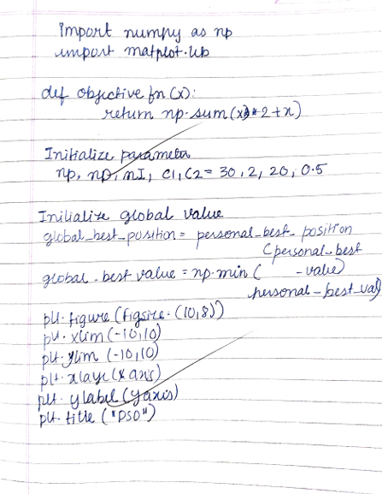

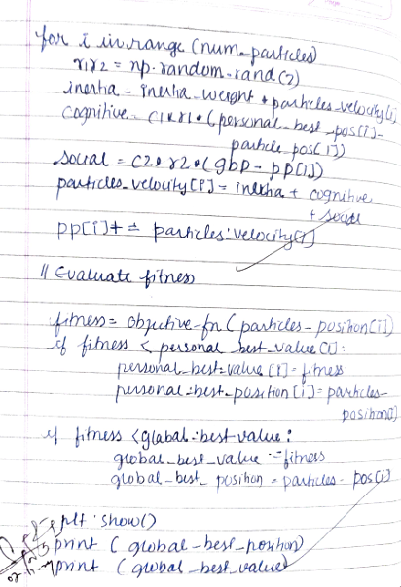

Code:

import numpy as np

import matplotlib.pyplot as plt

# Objective function: f(x) = x^2 + 4x + 4 def objective_function(x):

return x**2 + 4*x + 4

# PSO parameters

num_particles = 30 # Number of particles

dimensions = 1 # Problem dimensionality (1D for this example) iterations = 100 # Number of iterations

w = 0.5 # Inertia weight

c1 = 1.5 # Cognitive coefficient

c2 = 1.5 # Social coefficient

# Initialize the particles

positions = np.random.uniform(-10, 10, size=(num_particles, dimensions)) # Random positions velocities = np.random.uniform(-1, 1, size=(num_particles, dimensions)) # Random velocities personal_best_positions = np.copy(positions) # Personal best positions

personal_best_scores = np.array([objective_function(p) for p in positions]) # Personal best scores

# Global best (initially the best personal position)

global_best_position = personal_best_positions[np.argmin(personal_best_scores)] global_best_score = np.min(personal_best_scores)

# PSO Optimization loop

for iteration in range(iterations): for i in range(num_particles):

# Update velocity

r1 = np.random.rand() r2 = np.random.rand()

velocities[i] = w * velocities[i] + c1 * r1 * (personal_best_positions[i] - positions[i]) + c2 * r2 * (global_best_position - positions[i])

# Update position

positions[i] = positions[i] + velocities[i]

# Evaluate the objective function

current_score = objective_function(positions[i])

# Update personal best

if current_score < personal_best_scores[i]: personal_best_scores[i] = current_score personal_best_positions[i] = positions[i]

# Update global best

if current_score < global_best_score: global_best_score = current_score

global_best_position = positions[i]

# Optionally print the global best score during the iterations if iteration % 10 == 0:

print(f"Iteration {iteration}: Global Best Score = {global_best_score}")

# Final result

print(f"Final Global Best Position: {global_best_position}") print(f"Final Global Best Score: {global_best_score}")

# Plotting the results for visualization x = np.linspace(-10, 10, 400)

y = objective_function(x)

plt.plot(x, y, label="Objective Function: f(x) = x^2 + 4x + 4", color='blue') plt.scatter(global_best_position, global_best_score, color='red', label=f"Global Best:

{global_best_position[0]:.2f}") plt.legend()

plt.title("Particle Swarm Optimization Result") plt.xlabel("x")

plt.ylabel("f(x)") plt.show()

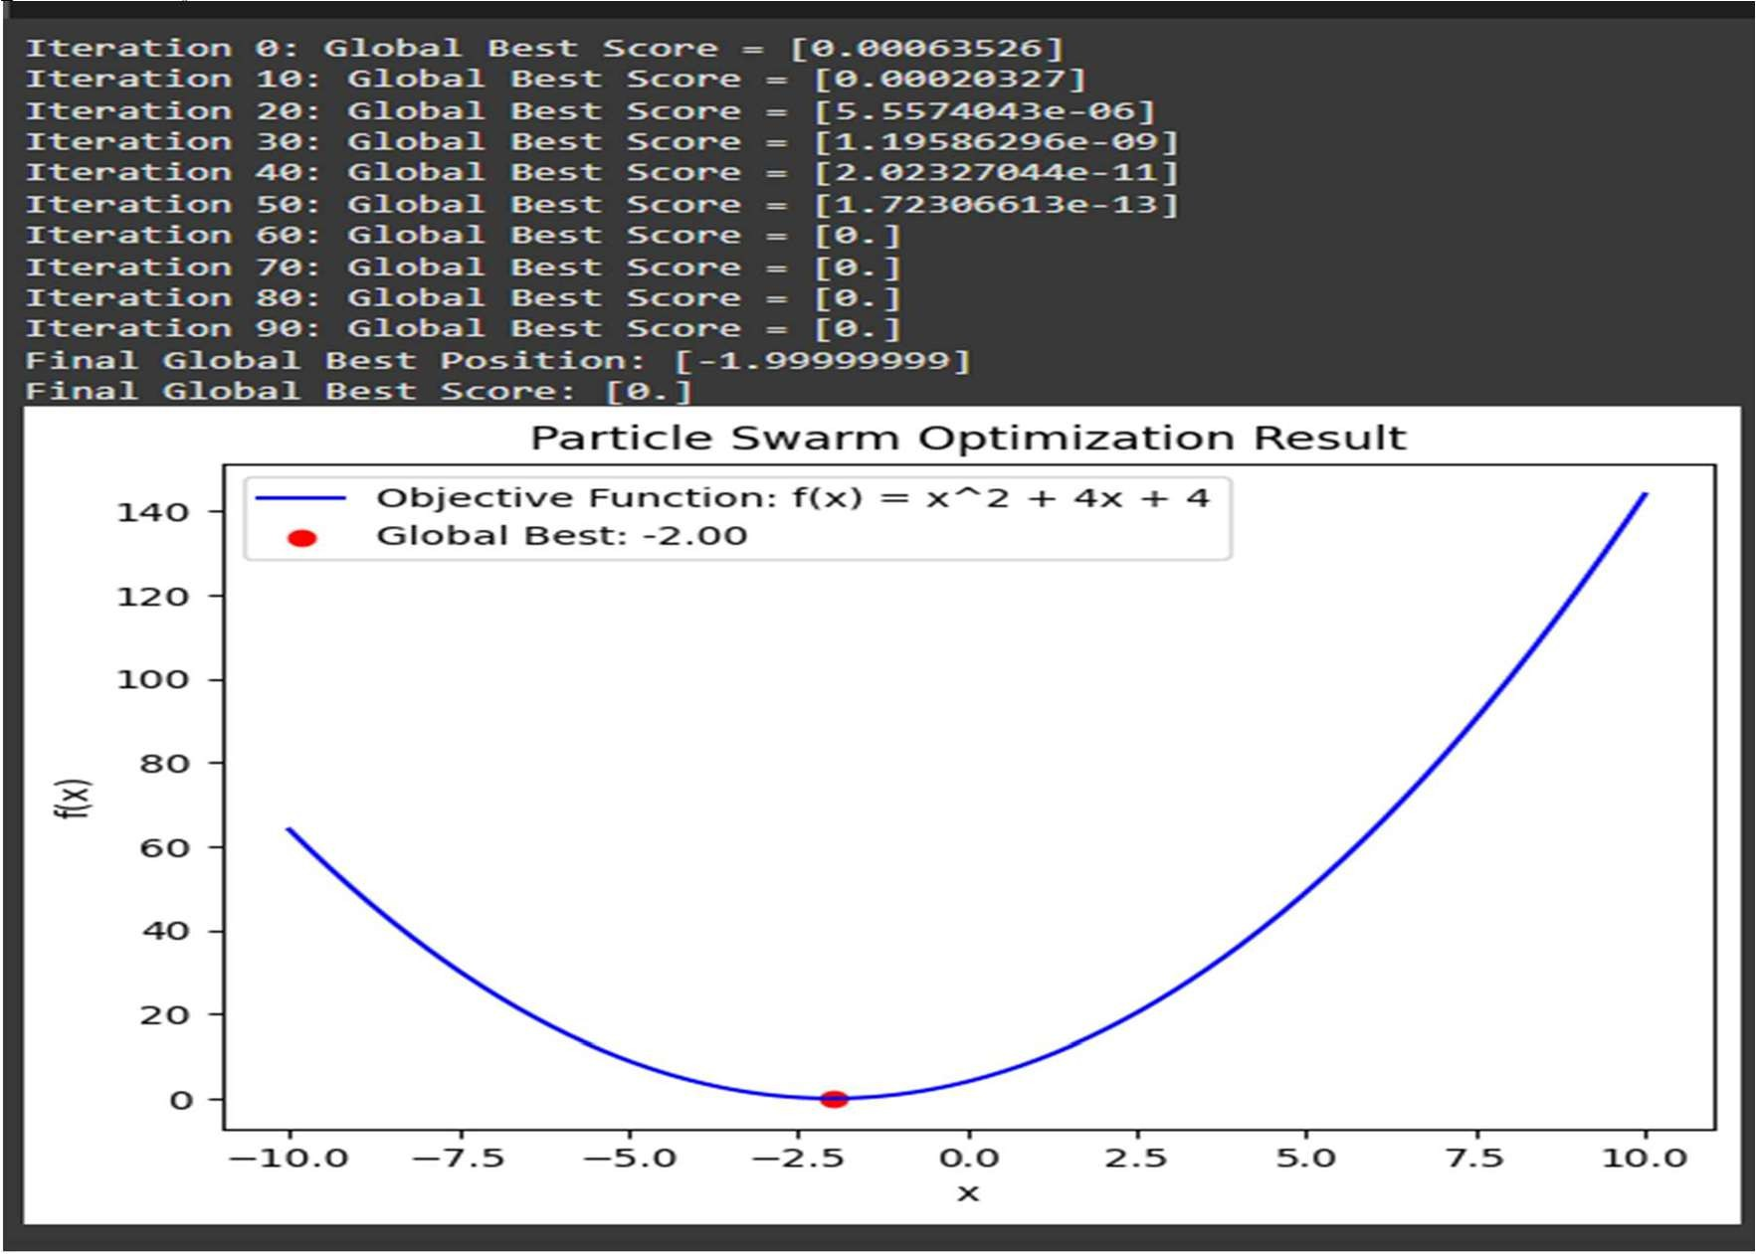

# Program 3

## Ant Colony Optimization for the Traveling Salesman Problem

Algorithm:

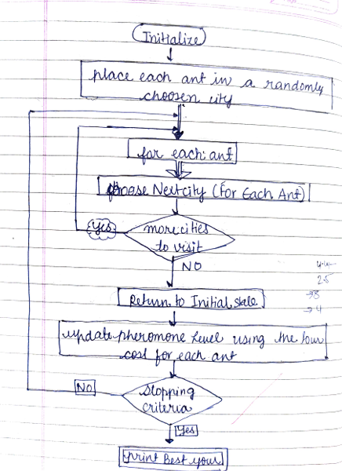

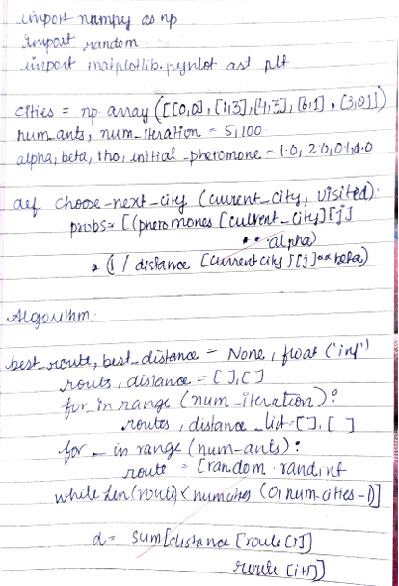

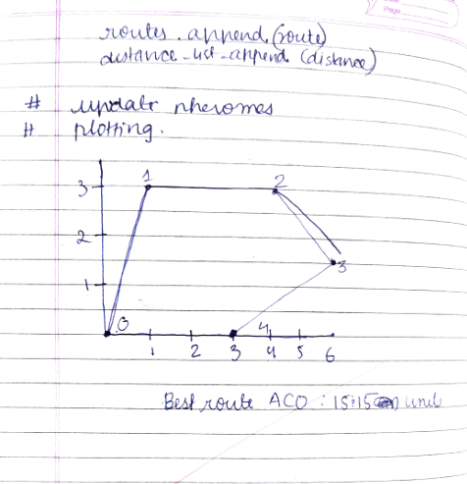

Code:

import random import math

import numpy as np

# Calculate the Euclidean distance between two cities def distance(city1, city2):

return math.sqrt((city1[0] - city2[0])**2 + (city1[1] - city2[1])**2)

# Ant Colony Optimization for TSP class AntColony:

def init (self, cities, num_ants, alpha, beta, rho, iterations): self.cities = cities

self.num_cities = len(cities) self.num_ants = num_ants

self.alpha = alpha # Influence of pheromone self.beta = beta # Influence of distance self.rho = rho # Pheromone evaporation rate self.iterations = iterations

self.pheromone = np.ones((self.num_cities, self.num_cities)) # Initial pheromone self.distances = np.zeros((self.num_cities, self.num_cities))

# Calculate the distance matrix for all pairs of cities for i in range(self.num_cities):

for j in range(i + 1, self.num_cities):

self.distances[i][j] = distance(self.cities[i], self.cities[j]) self.distances[j][i] = self.distances[i][j]

def probability(self, ant, city, visited):

"""Calculates the probability of moving to a next city.""" pheromone = self.pheromone[city]

heuristic = np.array([1.0 / self.distances[city][i] if i not in visited else 0 for i in range(self.num_cities)])

pheromone_heuristic = pheromone ** self.alpha * heuristic ** self.beta pheromone_heuristic[visited] = 0 # Ensure no city is visited twice

return pheromone_heuristic / pheromone_heuristic.sum() def run(self):

best_distance = float('inf') best_tour = None

# Iterate for a number of iterations for _ in range(self.iterations):

all_tours = [] all_distances = []

# Each ant constructs a solution for ant in range(self.num_ants):

visited = [0] # Start from city 0 tour = [0]

total_distance = 0

# Construct the solution by visiting all cities while len(visited) < self.num_cities:

city = visited[-1]

prob = self.probability(ant, city, visited)

next_city = np.random.choice(range(self.num_cities), p=prob) visited.append(next_city)

tour.append(next_city)

total_distance += self.distances[city][next_city]

# Add the return to the starting city

total_distance += self.distances[visited[-1]][visited[0]]

# Track the best tour and distance all_tours.append(tour) all_distances.append(total_distance)

if total_distance < best_distance: best_distance = total_distance best_tour = tour

# Update pheromone trails

self.pheromone *= (1 - self.rho) # Evaporate pheromone for ant in range(self.num_ants):

for i in range(self.num_cities - 1): city1 = all_tours[ant][i]

city2 = all_tours[ant][i + 1]

self.pheromone[city1][city2] += 1.0 / all_distances[ant] # Pheromone reinforcement self.pheromone[city2][city1] += 1.0 / all_distances[ant]

return best_tour, best_distance # Example usage

if name == " main ":

# Define cities as a list of (x, y) coordinates

cities = [(0, 0), (1, 3), (4, 3), (6, 1), (6, 5), (2, 7), (3, 4), (5, 2)]

# Set the ACO parameters num_ants = 10

alpha = 1.0 # Pheromone importance beta = 2.0 # Heuristic importance rho = 0.1 # Pheromone evaporation

iterations = 100

# Create and run the ant colony optimizer

aco = AntColony(cities, num_ants, alpha, beta, rho, iterations) best_tour, best_distance = aco.run()

# Output the best solution found print("Best tour:", best_tour) print("Best distance:", best_distance)

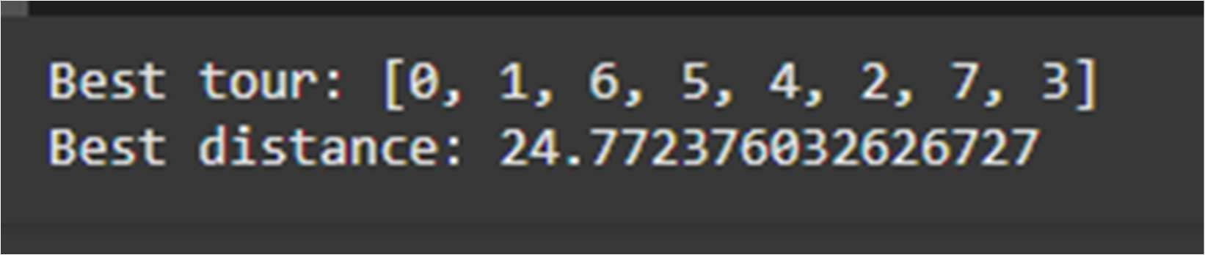

Algorithm:

# Program 4

## Cuckoo Search (CS)

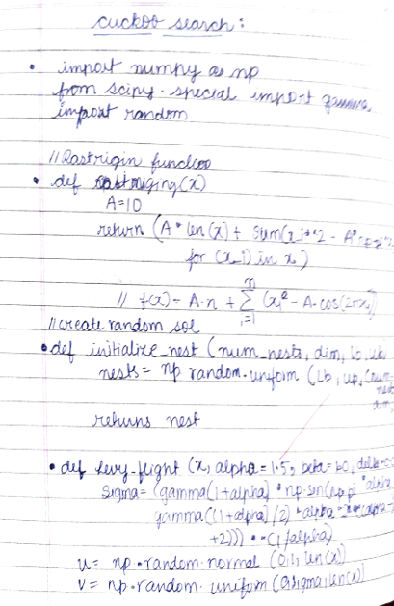

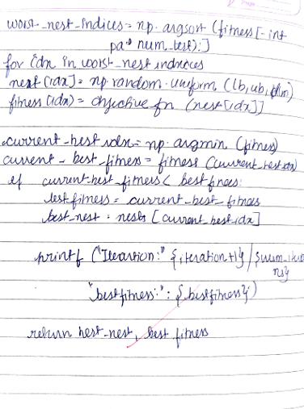

Code:

import numpy as np import math

# Sphere Function: f(x) = sum(x_i^2) def sphere_function(x):

return np.sum(x**2)

# Lévy Flight function

def levy_flight(Lambda, d):

# Lévy flight step size based on power-law distribution

sigma_u = (math.gamma(1 + Lambda) * np.sin(np.pi * Lambda / 2) /

(math.gamma((1 + Lambda) / 2) * Lambda * 2**((Lambda - 1) / 2)))**(1 / Lambda) u = np.random.normal(0, sigma_u, d)

v = np.random.normal(0, 1, d) step = u / np.abs(v)**(1 / Lambda) return step

# Initialize the Cuckoo Search Algorithm

def cuckoo_search(func, n_nests, n_dim, max_iter, pa=0.25, alpha=0.01, lambda_levy=1.5): # Initialize nests randomly

nests = np.random.uniform(-5, 5, (n_nests, n_dim)) # Bound the values between -5 and 5 for the Sphere function

fitness = np.apply_along_axis(func, 1, nests) # Calculate fitness of each nest

# Keep track of the best solution found so far best_nest = nests[np.argmin(fitness)] best_fitness = np.min(fitness)

for iteration in range(max_iter):

# Generate new nests via Lévy flights

new_nests = nests + alpha * levy_flight(lambda_levy, n_dim) # Ensure new nests are within bounds

new_nests = np.clip(new_nests, -5, 5)

# Evaluate new nests' fitness

new_fitness = np.apply_along_axis(func, 1, new_nests)

# Replace worst nests with new ones based on probability of discovery for i in range(n_nests):

if np.random.rand() < pa: # Discovery probability nests[i] = new_nests[i]

fitness[i] = new_fitness[i]

# Update the best solution if we find a better one if np.min(fitness) < best_fitness:

best_fitness = np.min(fitness)

best_nest = nests[np.argmin(fitness)]

# Output the current iteration's best solution return best_nest, best_fitness

# Set algorithm parameters

n_nests = 50 # Number of nests (solutions)

n_dim = 10 # Dimensionality of the problem (number of variables) max_iter = 100 # Number of iterations

pa = 0.25 # Probability of discovery (abandoning the worst nests) alpha = 0.01 # Scaling factor for the Lévy flight

lambda_levy = 1.5 # Exponent for Lévy flight distribution

# Run the Cuckoo Search Algorithm to minimize the Sphere Function

best_solution, best_value = cuckoo_search(sphere_function, n_nests, n_dim, max_iter)

# Output the best solution found

print("\nBest Solution Found:", best_solution) print("Best Fitness Value:", best_value)

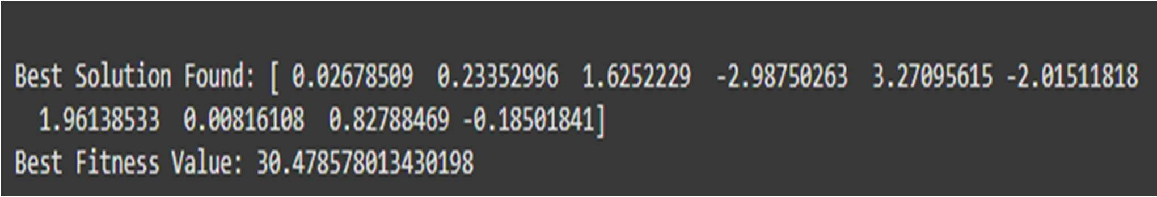

Algorithm:

# Program 5

## Grey Wolf Optimizer (GWO)

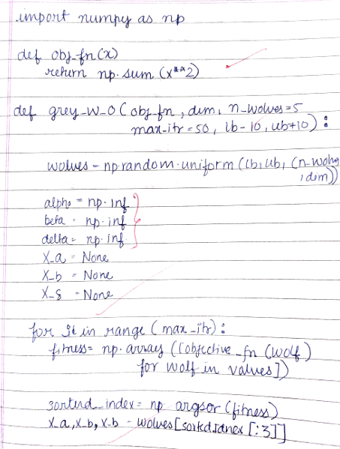

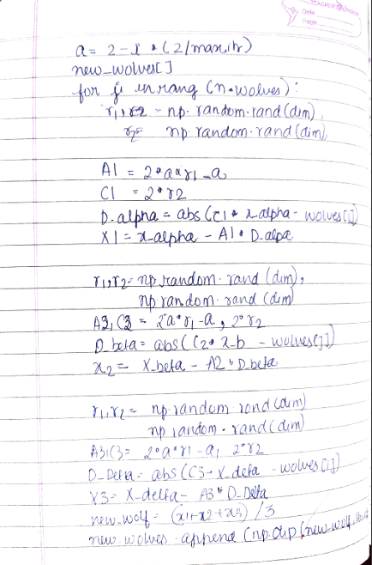

Code:

import numpy as np

# Define the objective function (Sphere function: sum(x^2)) def sphere(x):

return np.sum(x**2)

# Grey Wolf Optimizer (GWO) class GWO:

def init (self, obj_func, dim, pop_size, max_iter, lb, ub): self.obj_func = obj_func # Objective function to minimize self.dim = dim # Number of dimensions

self.pop_size = pop_size # Number of wolves in the population self.max_iter = max_iter # Maximum number of iterations self.lb = lb # Lower bound of search space

self.ub = ub # Upper bound of search space

# Initialize the wolves' positions randomly within bounds

self.position = np.random.uniform(self.lb, self.ub, (self.pop_size, self.dim))

self.fitness = np.array([self.obj_func(ind) for ind in self.position]) # Initial fitness of all wolves

# Initialize the alpha, beta, and delta wolves' positions and fitness self.alpha_pos = np.zeros(self.dim)

self.beta_pos = np.zeros(self.dim) self.delta_pos = np.zeros(self.dim)

self.alpha_score = float('inf') # Best score (we minimize, so start with infinity) self.beta_score = float('inf')

self.delta_score = float('inf')

def update_position(self, alpha, beta, delta, a, A, C, position):

# Update the position of a single wolf based on the positions of alpha, beta, delta r1 = np.random.random(self.dim)

r2 = np.random.random(self.dim)

# Update position using the equation D_alpha = abs(C[0] * r1 - position - alpha) D_beta = abs(C[1] * r1 - position - beta) D_delta = abs(C[2] * r1 - position - delta)

X1 = alpha - A[0] * D_alpha X2 = beta - A[1] * D_beta X3 = delta - A[2] * D_delta

# New position is the average of the three components new_position = (X1 + X2 + X3) / 3

return new_position

def optimize(self):

for t in range(self.max_iter):

# Update parameters A and C based on the iteration

a = 2 - t * (2 / self.max_iter) # Declining over iterations A = np.random.uniform(-a, a, 3)

C = np.random.uniform(0, 2, 3)

# Evaluate fitness and update the alpha, beta, delta wolves for i in range(self.pop_size):

fitness = self.obj_func(self.position[i])

if fitness < self.alpha_score: self.alpha_score = fitness self.alpha_pos = self.position[i]

elif fitness < self.beta_score: self.beta_score = fitness self.beta_pos = self.position[i]

elif fitness < self.delta_score: self.delta_score = fitness self.delta_pos = self.position[i]

# Update the position of each wolf in the population for i in range(self.pop_size):

# Update the position of wolf i

self.position[i] = self.update_position(self.alpha_pos, self.beta_pos, self.delta_pos, a, A, C, self.position[i])

# Ensure the new position stays within the bounds self.position[i] = np.clip(self.position[i], self.lb, self.ub)

# Optionally print the progress

print(f"Iteration {t+1}/{self.max_iter} - Best Fitness: {self.alpha_score}") return self.alpha_pos, self.alpha_score

# Set problem-specific parameters

dim = 10 # Number of dimensions (variables in the function) pop_size = 50 # Number of wolves in the population

max_iter = 100 # Number of iterations

lb = -5.12 # Lower bound of search space ub = 5.12 # Upper bound of search space

# Create an instance of the GWO class

gwo = GWO(obj_func=sphere, dim=dim, pop_size=pop_size, max_iter=max_iter, lb=lb, ub=ub)

# Run the optimization

best_pos, best_score = gwo.optimize() print("\nOptimization Complete!")

print("Best Solution (Position):", best_pos) print("Best Fitness (Value):", best_score)

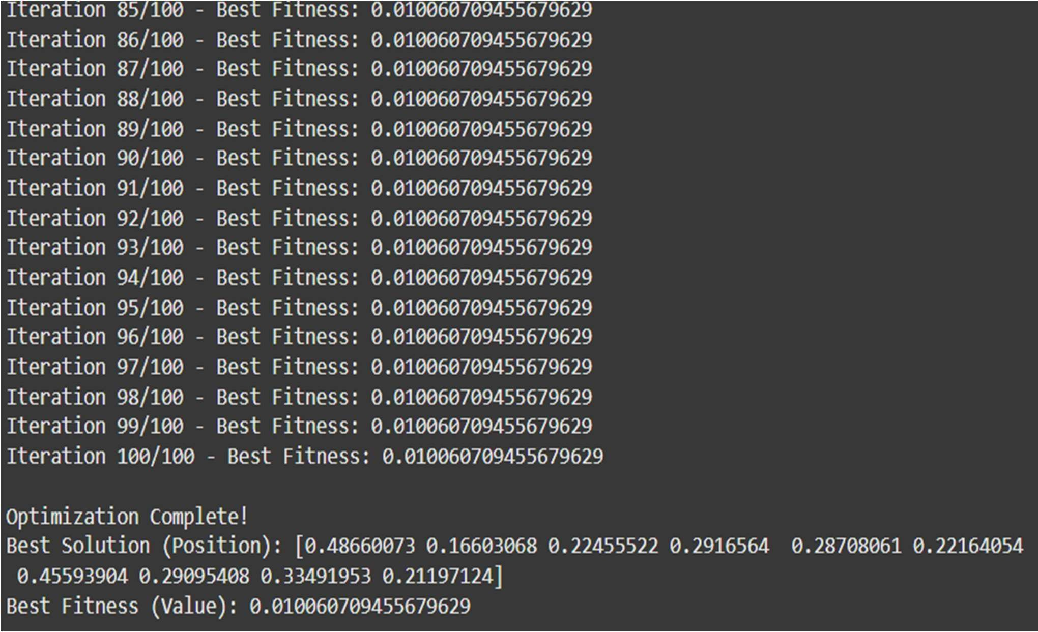

Algorithm:

# Program 6

## Parallel Cellular Algorithms and Programs

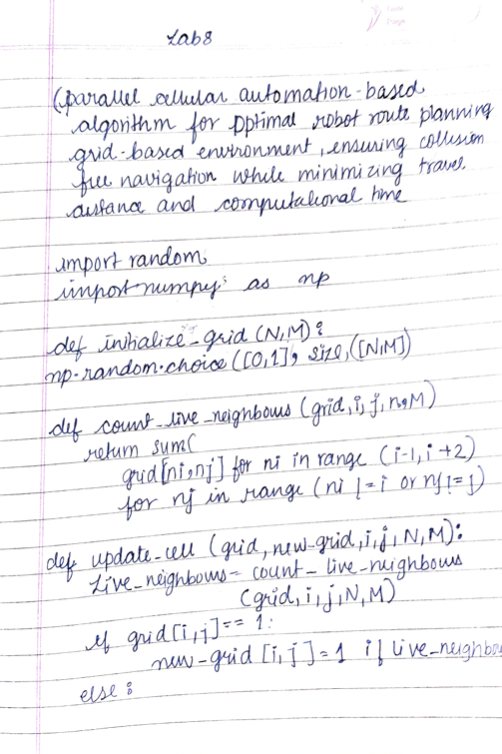

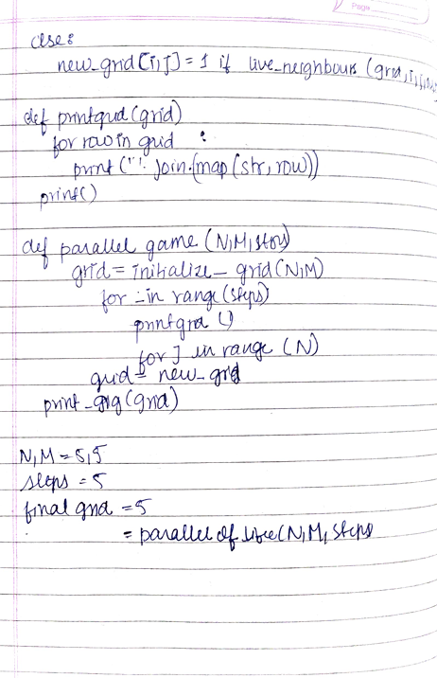

Code:

import numpy as np import random

# Objective function: f(x) = x^2 + 4x + 4 def objective_function(x):

return x**2 + 4*x + 4

# Parameters

grid_size = 10 # Number of cells in the grid (1D grid here for simplicity) num_iterations = 100 # Number of iterations

neighborhood_radius = 1 # Neighborhood range (cell's neighbors) mutation_rate = 0.1 # Probability of mutation

# Initialize the grid: random values within a range (-10, 10) def initialize_grid(grid_size):

return np.random.uniform(-10, 10, grid_size)

# Fitness evaluation for each cell def evaluate_fitness(grid):

return np.array([objective_function(cell) for cell in grid])

# Update the state of each cell based on its neighbors def update_states(grid, fitness, neighborhood_radius):

new_grid = np.copy(grid) for i in range(grid_size):

# Get the neighbors (with wraparound at boundaries) left = (i - neighborhood_radius) % grid_size

right = (i + neighborhood_radius) % grid_size

# Ensure that the indices are valid if left <= right:

neighbors = grid[left:right+1] fitness_neighbors = fitness[left:right+1]

else:

# Handle wraparound correctly

neighbors = np.concatenate([grid[left:], grid[:right+1]]) fitness_neighbors = np.concatenate([fitness[left:], fitness[:right+1]])

# Update rule: take the average of neighbors if their fitness is better best_neighbor = neighbors[np.argmin(fitness_neighbors)]

# Update rule: Apply smaller mutation

new_grid[i] = best_neighbor + random.uniform(-mutation_rate / 10, mutation_rate / 10) #

Reduced mutation impact return new_grid

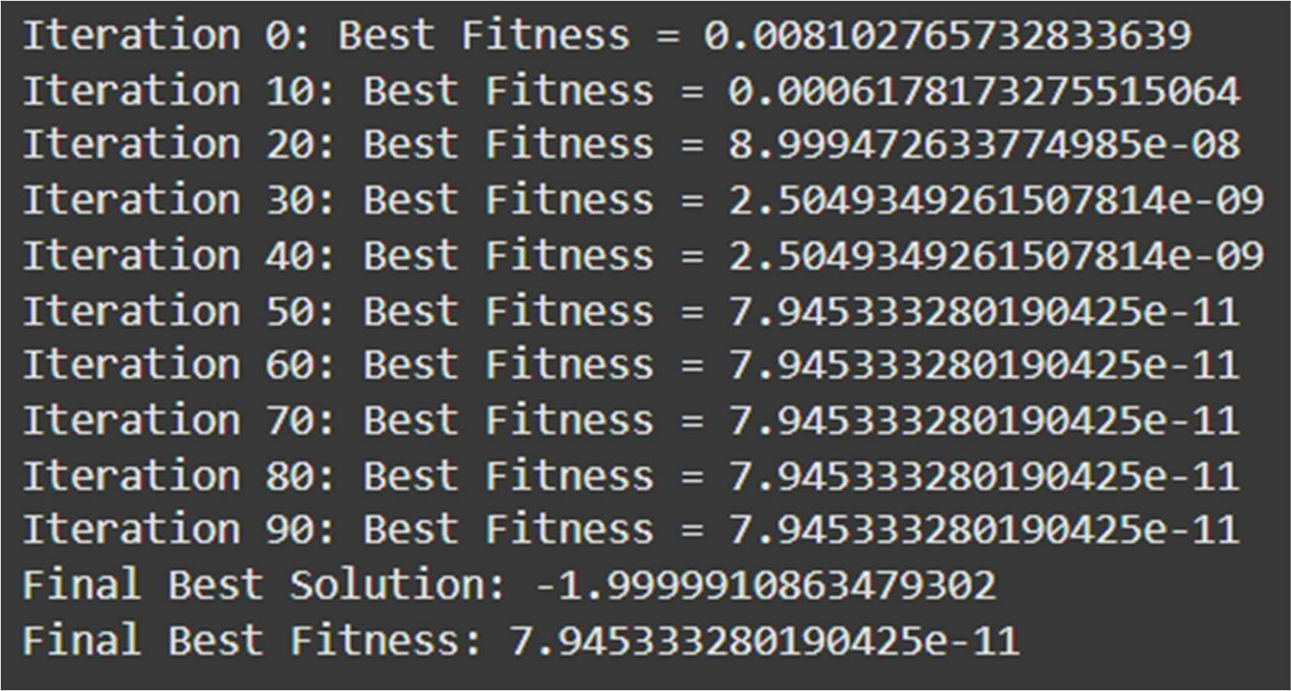# Main Cellular Algorithm Function def parallel_cellular_algorithm():

# Initialize grid

grid = initialize_grid(grid_size)

best_solution = None best_fitness = float('inf')

# Iterate through generations

for iteration in range(num_iterations): fitness = evaluate_fitness(grid)

# Track the best solution current_best_index = np.argmin(fitness)

if fitness[current_best_index] < best_fitness: best_fitness = fitness[current_best_index] best_solution = grid[current_best_index]

# Update states based on neighbors

grid = update_states(grid, fitness, neighborhood_radius)

# Output the best solution at regular intervals if iteration % 10 == 0:

print(f"Iteration {iteration}: Best Fitness = {best_fitness}") return best_solution, best_fitness

# Run the Parallel Cellular Algorithm

best_solution, best_fitness = parallel_cellular_algorithm()

# Output the final best solution

print(f"Final Best Solution: {best_solution}") print(f"Final Best Fitness: {best_fitness}")

Algorithm:

# Program 7

## Optimization via Gene Expression Algorithms

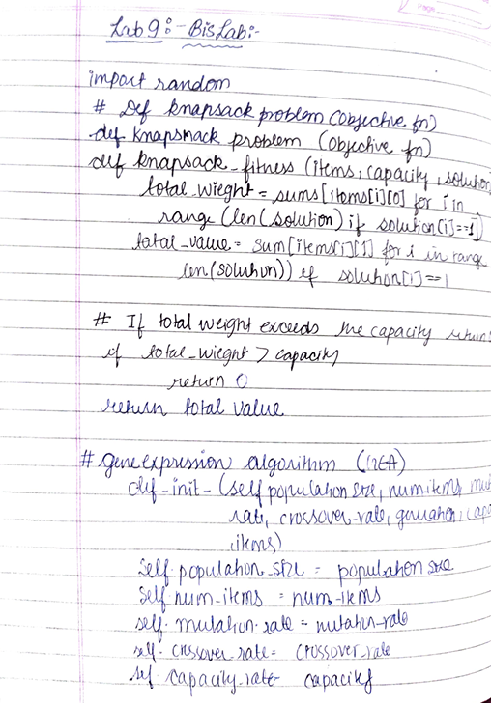

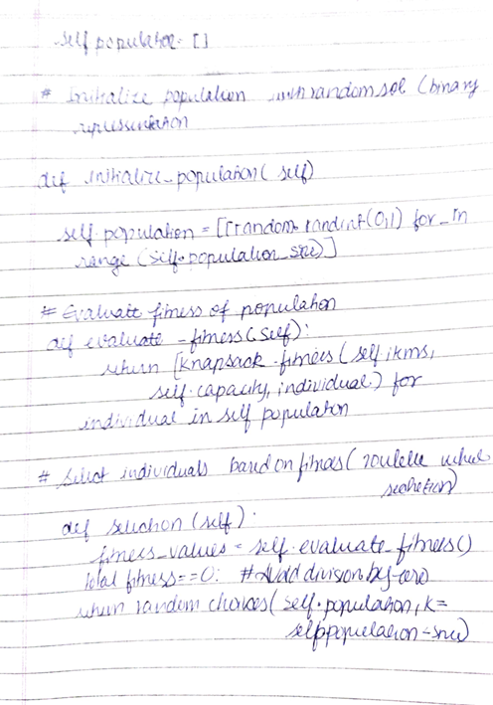

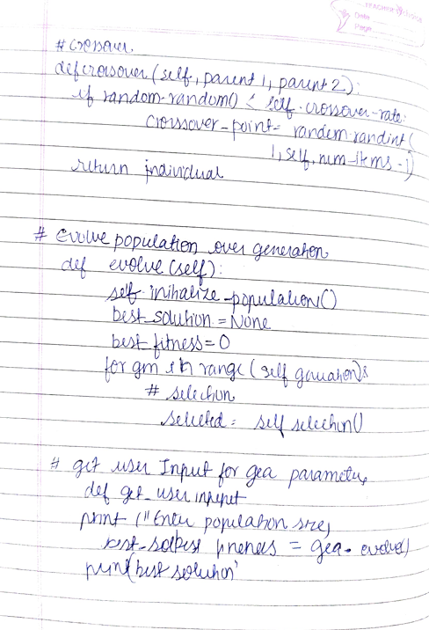

Code:

import numpy as np import random

# Objective function: f(x) = x^2 + 4x + 4 def objective_function(x):

return x**2 + 4*x + 4

# GEA parameters

population_size = 30 # Number of genetic sequences (solutions)

num_genes = 1 # Number of genes in each sequence (1D optimization in this case) mutation_rate = 0.05 # Probability of mutation

crossover_rate = 0.7 # Probability of crossover num_generations = 100 # Number of generations

# Initialize Population: Generate random genetic sequences (chromosomes) def initialize_population(population_size, num_genes):

return np.random.uniform(-10, 10, (population_size, num_genes))

# Fitness Evaluation: Evaluate fitness of each sequence def evaluate_fitness(population):

return np.array([objective_function(individual[0]) for individual in population])

# Selection: Tournament Selection def select(population, fitness):

selected_indices = np.random.choice(len(population), size=2, replace=False) return population[selected_indices[np.argmin(fitness[selected_indices])]]

# Crossover: Single-point crossover def crossover(parent1, parent2):

if random.random() < crossover_rate:

# Random crossover point (for 1D, just average)

return (parent1 + parent2) / 2 return parent1

# Mutation: Introduce small random changes def mutate(individual):

if random.random() < mutation_rate:

return individual + np.random.uniform(-1, 1) return individual

# Gene Expression: Translate genetic sequence to a functional solution def gene_expression(population):

return population

# Main GEA Function: Optimization Loop def gene_expression_algorithm():

# Initialize population

population = initialize_population(population_size, num_genes)

best_solution = None best_fitness = float('inf')

# Track the best solution through generations for generation in range(num_generations):

fitness = evaluate_fitness(population)

# Track the best solution current_best_index = np.argmin(fitness)

if fitness[current_best_index] < best_fitness: best_fitness = fitness[current_best_index] best_solution = population[current_best_index]

# Create a new population new_population = []

for _ in range(population_size): parent1 = select(population, fitness) parent2 = select(population, fitness)

offspring = crossover(parent1, parent2) offspring = mutate(offspring) new_population.append(offspring)

population = np.array(new_population)

# Gene expression (translation of genetic sequence to solutions) population = gene_expression(population)

# Output the best solution at regular intervals if generation % 10 == 0:

print(f"Generation {generation}: Best Fitness = {best_fitness}") return best_solution, best_fitness

# Run the GEA

best_solution, best_fitness = gene_expression_algorithm()

# Output final best solution

print(f"Final Best Solution: {best_solution}") print(f"Final Best Fitness: {best_fitness}")

